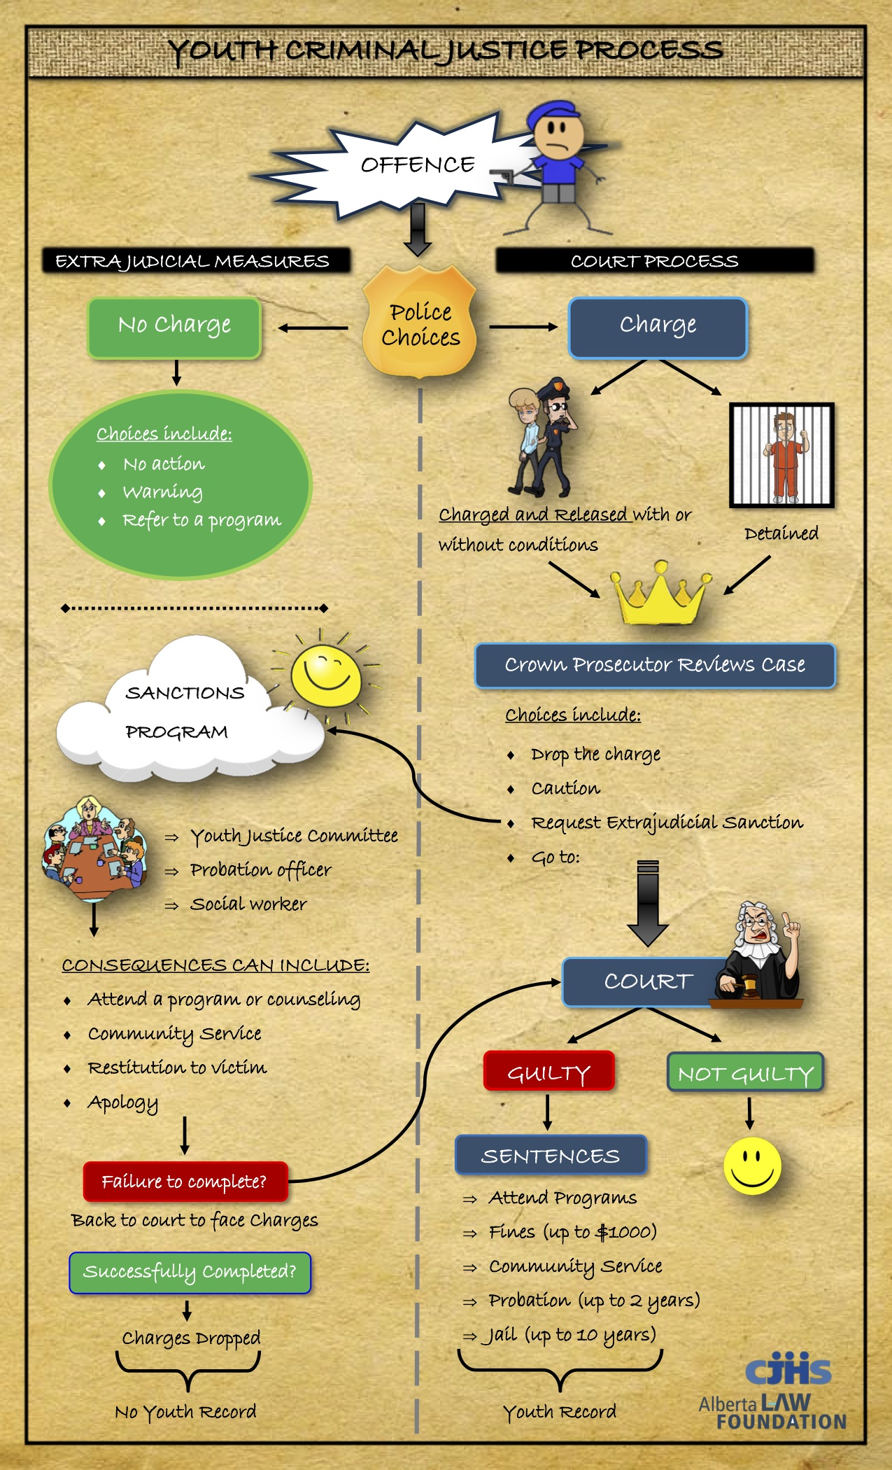
YCJA Flow Chart Assignment:
A Journey Through the Justice System

We will read articles surrounding a youth committing a crime. It will be your job to draw a flowchart for the Young Offender to show the journey that a youth criminal would take through the justice system. You will decide what path you deem appropriate, based on the following:
- The seriousness of the offence
- The history of the young person (is this their first offence?)
- The attitude of the young person
- The circumstances of the young person (substance abuse, home problems etc.)
Use your best judgment to chart the process the criminal would go through, only using the necessary steps that apply.
Make sure to fill in specific details!
Use images and shapes such as arrows, circles and squares like the ones that are used in the textbook to enhance the content of your flow chart. Be sure to use the same symbols on both charts so that they match where it is appropriate.
Your assignment may be completed on paper or digitally.
For Digital Assignments:
Title for your document: HR-YCJA-Your Name/9B-YCJA-Brittany
Share with: liliznick@educbe.ca

Assessment for YCJA Flow Chart
CATEGORY | 4 | 3 | 2 | 1
Written Content (Stems 2,10)  -Have you edited your work for spelling grammar and sentence structure?  -Have you considered your audience and purpose? | - Writing has been carefully edited, is flawless, and communicates effectively with the audience.  -The flow chart is very informative to audience. | - Writing has clearly been edited, and communicates well with the audience.  - The flow chart is informative to audience. | -Writing has minimal errors, and communicates with the audience with only minor areas lacking in clarity.  -The flow chart slightly informs the reader. | -Writing has many errors, and does not communicate well with the audience.  -The audience of the flow chart is not considered.  -The flow chart is not informative to the reader.  OR  - The flow chart is not complete.
Content & Detail (Stems 5,7)  -Have you recorded accurate facts from the film in detail?  - There is a clear understanding of the YCJA process as it applies to the young person.  - Do you have relevant images to bolster your written work? | -A thorough and complete summary of the young person’s crimes and consequences are presented in very strong and clear detail.  -The flow chart shows a sophisticated understanding of the complexities of the YCJA process.  -The images are exceptionally neat and relevant to the topic. | - An appropriate summary of the young person’s crimes and consequences are presented in detail.  -The flow chart shows a clear understanding of the complexities of the YCJA process.  -The images are neat and relevant to the topic. | -Points of the young person’s crimes and consequences are missing, or it is not clear whether student understands them.  -The flow chart shows a basic understanding of the complexities of the YCJA process.  - There are a few images to support the content. | - Major points of the young person’s crimes and consequences are missing.  -The flow chart shows a lack of understanding of the complexities of the YCJA process.  - There are no images or very few to support the content.  OR  - The flow chart is not complete or the information is incorrect.
Organization (Stems 3,10)  - Is your flow chart organized into sections that are appropriate for the audience and purpose? | Information in the flow chart is clearly organized into appropriate sections according to the content presented. | Information in the flow chart is clearly organized into sections however details may lack clarity or are repeated in the brochure. | Information in the flow chart is organized into sections however these headings may be inappropriate or may be too general. | The flow chart does not contain headings or sections.  OR  - The flow chart is not complete.

