Topic 1-2 Assignment
Space Exploration
Name: ___________________________________
- When calculating the location of a celestial object in the sky, you require two values: azimuth and altitude. Which of the following answers refers to azimuth?
a. | 254°
b. | 90° down
c. | 270° above the horizon
d. | 90° above the horizon

- When Galileo observed the Sun, he noticed that spots on the Sun’s surface moved little by little. During the course of a month, the spots returned to their original positions. What did he infer as the reason for the movement of the spots?

  - The Sun rotates on its axis.
  - The spots floated on the Sun’s surface.
  - The spots were celestial bodies that moved between the Sun and Earth.
  - The surface of the Sun moves in convection currents.

- How did Copernicus’ observations of Jupiter support the heliocentric model of the universe?

  - Jupiter is in orbit around the Sun.
  - Jupiter’s moons travel in a geocentric pattern.
  - Jupiter has a longer night than day.
  - The moons orbit Jupiter instead of the Earth.

The following diagram shows light from the Moon traveling through a telescope. Use this information for the next two (2) questions
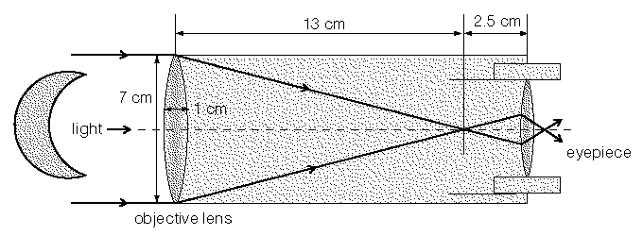

- Using the diagram above, which of the following are the two main parts of a simple telescope?

  - Objective lens and plane lens
  - Plane lens and ocular lens
  - Ocular lens and objective lens
  - Ocular lens and eyepiece

- Using the diagram above, what is the focal length of the objective lens?

  - 13 cm
  - 7 cm
  - 1 cm
  - 2.5 cm

- You are selecting a new telescope to purchase. You are choosing between a refracting and a reflecting model. If the refractor and reflector are of the same size, which of the following statements is true?

  - The refractor will produce a better image.
  - The refractor will produce an image of lower quality.
  - The reflector will produce a better image.
  - The images will be of equal quality.

- Johannes Kepler was a German mathematician who described the orbits of the planets as elliptical. But it took another eighty (80) years until __________________ stated the law of Universal Gravitation that provided an explanation for the planets’ elliptical orbits. Who was the person to state the law of Universal Gravitation?

  - Lippershey
  - Ptolemy
  - Galileo
  - Newton

- Which of the following illustrates the Sun and a planet's orbital relationship, as we understand it today?
  - I
  - II
  - III
  - IV
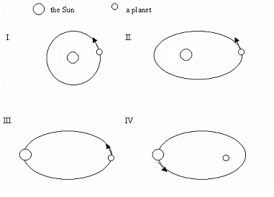
When Jupiter is viewed with a telescope that is orbiting Earth, its image appears clearer than it does when viewed with a telescope positioned on Earth’s surface.

- The reason that the image of Jupiter appears clearer through the orbiting telescope is that in space,

a. the telescope is closer to its subject.
b. more light s available for the telescope.
c. there is little gravity to distort the image.
d. there is little atmosphere to distort the image.

In a space station experiment, a biologist compared the growth rate of four different plants. She exposed the plants to different concentrations of carbon dioxide gas for a fixed period of time and kept them all under a grow light for 12 h each day. The growth of each plant was monitored.

- The responding variable in this experiment was the

a. Temperature
b. Exposure to light
c. Growth rate of plants
d. Concentration of carbon dioxide

Numerical Response 1. Match each part of the telescope numbered above with its name, as given below.

____ Secondary Mirror
____ Eyepiece
____ Aperture
____ Main Mirror

Record your 4 digit answer here: _____________

Numerical Response 2. If you have a telescope with an ocular (eye piece) focal length of 5 cm, and an objective lens with a focal length of 100 cm, what will the magnification of the telescope be?

Record your 4 digit answer here: _____________

Numerical Response 3.

