Chapter 3: Classifying Matter Graphic Organizer Assignment

Due:_______________________

Purpose:
- Classify various forms of matter, including commonly used household substances, on the basis of their properties.
- Compare and contrast the properties of pure substances and mixtures and relate this information to practical applications.

Assignment:
Create a graphic organizer based off of the classification of different forms of matter like below:
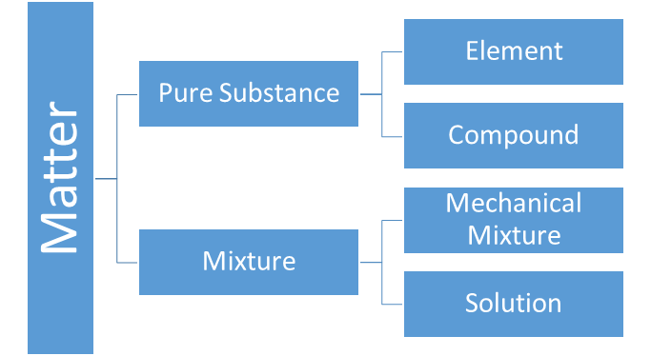

In your graphic organizer you will be expected to:
- Give a definition of: matter, pure substance, mixture, element, compound, mechanical mixture and solution in your own words.
- Cut out each of the examples of matter on the next page and classify them as either element, compound, mechanical mixture or solution. These are on page 3.
- Come up with 3 examples each of elements, compounds, mechanical mixtures and solutions that you encounter on a daily basis.
- For each of the examples that you thought of above, explain why it is an element, compound, mechanical mixture or solution. For example, regular nail polish is a solution because it contains a mixture of chemicals including colouring dye, organic solvent (to mix everything together) and nitrocellulose (a polymer that forms a film when dried). You cannot see these separate parts of the nail polish.

See the next page for the rubric (what is expected of you for this assignment).

Rubric:

Criteria | Aspiring | Emerging | Developing | Beginning
Presentation /5 | - graphic organizer is neatly organized and easily readable  - text is presented in an organized manner  - product reflects exceptional attention to detail | - graphic organizer is organized and easily readable  - text is mostly presented in an organized manner  - product reflects attention to detail | - graphic organizer is readable however reader must take extra effort in trying to decipher some information  - text contains lapses in attention to detail such as spelling errors | - graphic organizer is difficult to decipher between the different categories of manner  - Attention to detail is lacking
Definitions / 5  matter, pure substance, mixture, element, compound, mechanical mixture and solution | - Definitions are all accurate and written in own words.  - Definitions are well written and concise (to the point). | - Definitions are all accurate and written in own words. | - Definitions contain 1-2 errors | - Definitions contain more than 2 errors
Classification of matter /5  From cut outs | - The classification of matter from the cut-out examples are all correctly placed | - The classification of matter from the cut-out examples contain 1-2 errors | - The classification of matter from the cut-out examples contain 3-5 errors | - The classification of matter from the cut-out examples contain more than 5 errors
Examples and Explanation /10  Come up with your own examples of elements, compounds, mechanical mixtures and solutions | - The examples are correctly categorized.  - The categorization of examples is fully supported with explanation | - The examples are correctly categorized.  - The categorization of examples is contains explanation that could include more detail. | - 2-4 examples are incorrectly categorized.  - The categorization of examples contains explanation that is not complete or does not have enough detail. | - More than 5 own examples are incorrectly categorized.  - No explanation is provided for the examples.

2. Cut-Out Examples. Cut these examples of matter out and categorize them as either element, compound, mechanical mixture or solution on your graphic organizer. You may need to Internet research to determine what

oxygen | orange juice with pulp | windex cleaning solution | liquid foundation (makeup)
H₂O_{(l)} | Au_{(s)} | brass | steel
motor oil | propane gas | CO_{2(g)} | homogenized milk
silver | sterling silver | aluminum | road salt/ de-icing salt
wall paint | trail-mix (food) | gatorade | shampoo
bleach | perfume | vinegar | stirred yogurt

