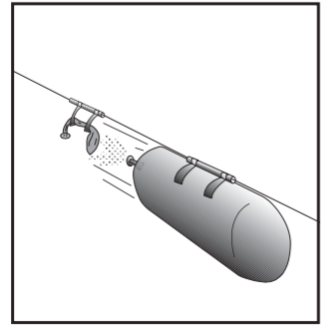
Rocket Staging (Adapted from NASA, 1996)

Objective:

To explore how different types of rocket staging affect the altitude of a rocket reached. You will compare unstaged, two-staged, three-staged and parallel staged rockets.

Background Information:

Travelling into outer space takes enormous amounts of energy. This activity is a simple demonstration of rocket staging that Johann Schmidlap first proposed in the 16th century. When a lower stage has exhausted its load of propellants, the entire stage drops away, making the upper stages more efficient in reaching higher altitudes.. In the typical rocket, the stages are mounted one on top of the other. The lowest stage is the largest and heaviest. In the Space Shuttle, the stages attach side by side. The solid rocket boosters attach to the side of the external tank. Also attached to the external tank is the Shuttle orbiter. When exhausted the solid rocket boosters jettison. Later, the orbiter discards the external tank as well.

Manipulated Variable:_____________________________________________________________________

Responding Variable:______________________________________________________________________

Controlled Variable(s) include at least 3:_______________________________________________

_________________________________________________________________________________________________

Control: ______________________________________________________________________________________

Materials:
Note that these are only the materials for the two-stage rocket. You will need to determine with your group what materials you will need for the unstaged rocket, 3 stage rocket, parallel staged rocket.
- 2 long party balloons
- fishing line
- 2 plastic straws
- Styrofoam coffee cup
- making tape
- scissors
- 2-spring clothespins
Procedure:
Note that this is only the procedure for the two-stage rocket. You will need to determine with your group how you will design the unstaged rocket, 3 stage rocket, parallel staged rocket.

Two-stage rocket building instructions
- Thread the fishing line through the two straws. Stretch the fishing line snugly across our classroom (width-wise) and secure its ends. Ask Ms. Ng for tape.
- Cut the coffee cup in half so that the lip of the cup forms a continuous ring.
- Stretch the balloons by pre-inflating them.
- Inflate the first balloon about three fourths full of air and squeeze its nozzle tight. Pull the nozzle through the ring. Twist the nozzle and hold it shut with a spring clothespin.
- Inflate the second balloon. While doing so, make sure the front end of the second balloon extends through the ring a short distance. As the second balloon inflates, it will press against the nozzle of the first balloon and take over the clip’s job of holding it shut. It may take a bit of practice to achieve this. Clip the nozzle of the second balloon shut also.
- Take the balloons to one end of the fishing line and tape each balloon to a straw with making tape. The balloons should point parallel to the fishing line.
- Remove the clip from the first balloon and untwist the nozzle. Remove the nozzle from the second balloon as well, but continue holding it shut with your fingers.
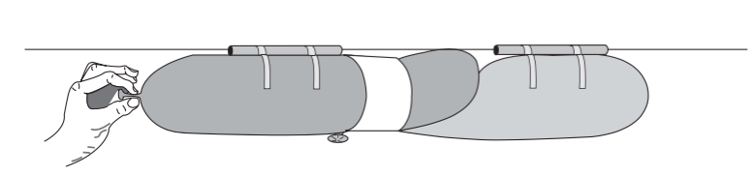
- If you wish, do a rocket countdown as you release the balloon you are holding. The escaping gas will propel both balloons along the fishing line. When the first balloon released runs out of air, it will release the other balloon to continue the trip.
- Measure how far from release your payload travels
- Record your observations in the observation table.

- Design your unstaged rocket, 3 stage rocket, parallel staged rocket on the following pages.
- Build the model using balloons and test these rockets making sure to measure how far the payload travels.
13) Record your observations in the observation table.

Design your unstaged rocket, 3 stage rocket, parallel staged rocket in the space below. Describe what each stage will do. Do not forget to include a place for your payload and crew. You do not need to include a step-by-step procedure of how you made each rocket.

Unstaged Rocket:
Diagram:

3-Stage Rocket
Diagram:

Parallel-Staged Rocket
Diagram:

Observations:
Title of Table:
Type of Rocket | Distance Payload Travels (cm)
Unstaged

Two-Staged

Three-Staged

Parallel-Staged

Analysis:
- What does the string length represent in real-life rocketry?

2)Which type of rocket travelled the farthest? Which type of rocket travelled the shortest? Explain why you think that is using the scientific principles involved in rocketry.

3) What sources of error may possibly have arisen during this experiment. Explain how these may have created misleading or faulty results. Name at least three.

