Master 1.18
Lesson 1.3: Surface Areas of Objects Made from Right Rectangular Prisms

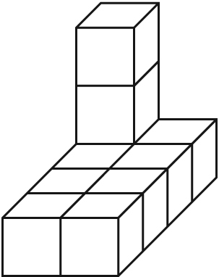
1. Each cube has edge length 1 unit.
Determine the surface a Extra Practice 3rea of each object.
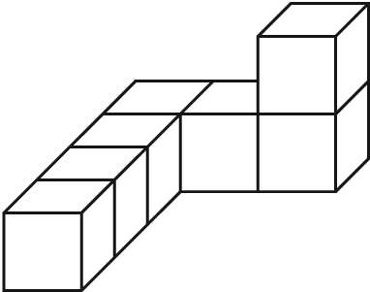
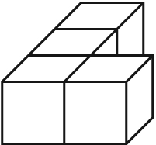
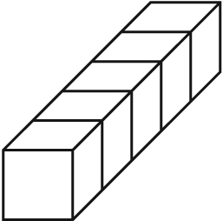
a) b) c) d)

2. Each edge of a linking cube is 1 unit long. Build a composite object with 7 linking cubes.
Exchange objects with a classmate. Determine the surface area of your classmate’s object. Check each other’s work.
3. Determine the surface area of this composite object.
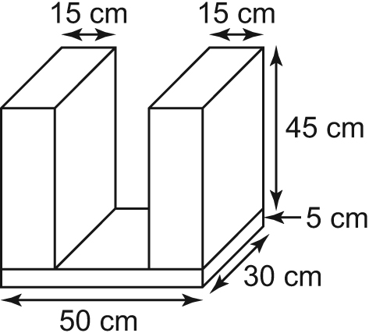

4. The local curling rink is shown
in the diagram at the right. It is to be painted.
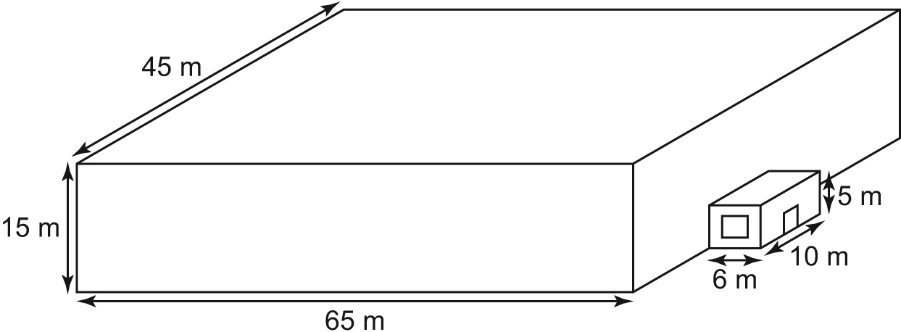
a) Determine the surface area of the structure.
b) The roof, windows, and door are
not to be painted. The door is 1 m by 2 m
and the window is 4 m by 2 m. Determine
the surface area to be painted.
c) A can of paint covers 300 m² and
costs $45. Determine the cost of the paint needed.

