Analyze one of the following cartoons below:
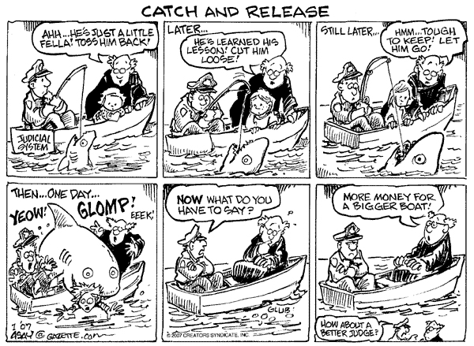
1

2
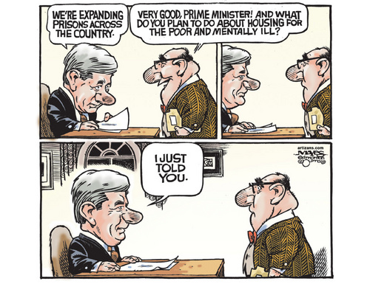

Source 1: Political Cartoon
Political Cartoon Choice:
- What do you see in the cartoon? List any of the following that appear:

People or characters
Text or speeches
Any other important details (Symbols, references, etc.)

/3
- What seems to be happening in this cartoon?

/1
- What is the issue being highlighted in this cartoon?

/2

- What seems to be the cartoonist’s position on this issue? Are they in favour or against Canada’s justice system? What do they like or dislike about it?

/3

