Building a Political Party
Task One: Create a Political Party

As a group, establish a party identity by creating the following:

- Party Name 3. Party Slogan
- Party Logo 4. Position on the spectrum

Task Two: Your Party Platform
Discuss and write down answers to the following questions. Your written answers will create your Party Policy (Platform). Choose a recorder… (as long as everyone is involved in the discussion) …

For Canada and Alberta…

Do you support Canadian “Social programs”?

- Universal Health
- Taxation
- Education Funding
- Environmental Issues
- Immigration
- Jobs
- Child Care
- Carbon Tax
- Pipelines

What measures will you take to save our environment?

For the schools of Canada…

Do you support Canada providing (at least 3 ideas) that will improve the education system in Canada?

Examples:
- Do you want to change our school’s nutrition standard?
- Ban junk foods from vending machines
- Implement school uniforms

How will you spend our “class tax”?
A preview of our nation’s political and their platforms cab be found on pgs. 287-290. May use current platforms from Political Parties.

Political Party Identity

Party Name: ______________________________

Party Logo:

A party logo should be something that is simple, yet memorable. Colour is important as well.
Here are a few examples of Logo’s from our federal parties:

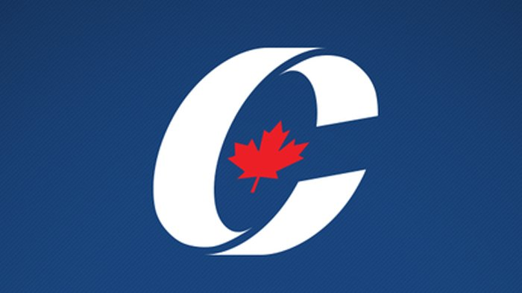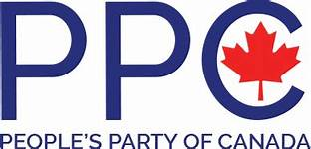

Party Slogan:
A party slogan shod be:
- Short
- Memorable
- Capture party’s philosophy

SLOGAN: __________________________________________________________

ECONOMIC SPECTRUM: Place your party where you think it belongs on the spectrum

Left _____________________________________________________________________________________________ Right

More Government Less

