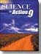

Section 1.0 Chemicals in the Environment can Support or Harm

Key Concepts • All things (living and non-living) are formed by chemicals.
Explain how Nitrogen is recycled in the environment, using this model of the Nitrogen Cycle.

Explain the term nitrogen fixation and why it has to occur.

Processes and Activities that affect Environmental chemicals.
Pollution is any change in the environment that produces a condition that is harmful to living things.

Describe cellular respiration. (p. 185)

Human Activities that affect the environment..
Describe how each of the following examples of Human Activities can affect the balance of chemicals in the environment. (p.186-188)

Human Activity | How it affects the balance of chemicals in the environment
Agriculture
Solid wastes
Wastewater
Fuel combustion
Industrial processes

Acids and Bases occur naturally and are measured by their pH
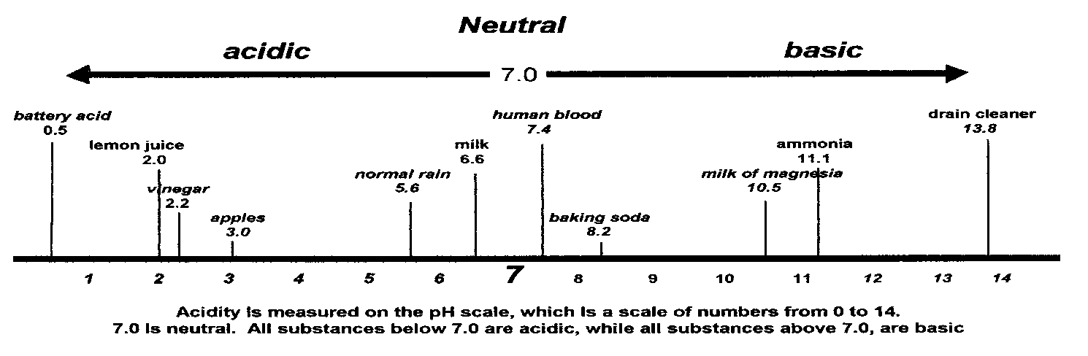
Explain the difference between an acid and a base. Give 3 examples of each.

Acid-base indicators measure pH.

What is pH a measure of?

Complete the table

Indicator | Indicator color
 | Acid | Neutral | Base
Bromothymol blue

In neutralization an acid and a base create a reaction.
Identify the reactants and the products in a neutralization reaction. Include a chemical formula that is an example of a neutralization reaction.

Reactants | Products

Example: (chemical formula)

Plants & animals need common elements such as C, H and O. Explain the difference between macronurients and micronutrients. Give 2 examples each of macronutrients and micronutrients

Optimum amounts of nutrients are need for good health What does ‘optimum amount’ mean?

Organic molecules contain carbon, inorganic molecules don’t
Identify the four classes of organic compounds and give examples of each.

Class of organic compound | Example 1 | Example 2 | Example 3

Describe the test used to identify the presence of each organic molecule.

Substance | Test
Glucose | Benedict’s solution turns from blue to yellow-orange-red
Starch | Iodine solution turns from red-brown to blue-black
Fat / Oil | Fats and oils leave a spot on brown paper that light can pass through
Protein | Biuret solution turns from blue to purple or mauve

Plants use inorganic substances to produce organic molecules
Describe 3 examples of how plants use inorganic molecules to make organic molecules. 1.
2.

3.

Plants take in substances through their roots by osmosis, animals ingest food and absorb nutrients in their blood.
Describe diffusion. Draw an illustration

Describe the process of osmosis using an illustration

Describe the process of active transport using an illustration

What is hydrolysis?

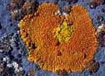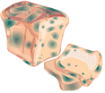Environments and substrates affect the availability of nutrients. Identify the substrate for each of the following organisms:
Lichen
Mold

Red Algae

Cactus

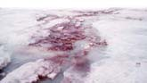

Identify what each number on the fertilizer bag stands for

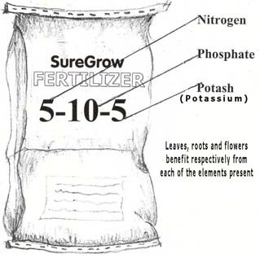
What does the other 80% include?

What are the advantages and disadvantages of using artificial fertilizers?
Advantages :

Disadvantages:

Section 2.0 Environmental Monitoring of Chemicals
Key Concepts
Water quality guidelines protect living things
List the five categories of water use which Provincial and Federal governments regulate for water quality:

For whom are these water quality guidelines designed to protect?

Chemical concentrations are measured in parts per million

Calculate the parts per million in the following example. Show your work.

Add 4ml of food coloring solution to 96ml of water

Calculate in ppm (parts per million) the amount of 1 milligram of mercury that was found in a barrel containing 30 Litres of water.

Biological indicators (invertebrates) and Chemical indicators (dissolved oxygen, phosphorus, nitrogen) measure water quality
Identify the 3 biological indicators

What are the 6 most common chemical indicators of water quality?

Science In Action 9 – Unit 3 Environmental Chemistry Summary of Key Concepts and Review Questions Booklet
What are the 4 factors that determine the amount of oxygen that can be dissolved in water?

Explain the term spring acid shock.

Explain the difference between acute and chronic toxicity.

What does LD50 refer to?

Give 2 examples of heavy metals. Why are heavy metals harmful?

How can air quality be measured?

What are catalytic converters used for and how effective are they?

What is a ‘scrubber’?

Explain the difference between point and non-point sources of pollution.
Carbon dioxide and Ozone are monitored globally What are the 3 major contaminants in the air?

Describe the ‘greenhouse effect’ and the ‘enhanced greenhouse effect’. Greenhouse effect -

Enhanced greenhouse effect -

What is the cause of climate change and what consequences are there if it is not controlled?

What is the role of CFC’s in the depletion of the Ozone layer?

Section 3.0 Harmful substances spread and are concentrated

What are the three stages of transport with regards to substances in the environment?

Stage 1

Stage 2

Stage 3

Airborne chemicals will travel certain distances and in certain directions depending on what?

Chemicals are dispersed, diluted and deposited by air, soil & water How can the movement of chemicals be controlled in the environment?

Groundwater can help to chemically change substances. Give 4 examples of how groundwater be contaminated?

Describe the difference between permeable and impermeable soil zones.

What is an aquifer?

Describe 3 substances that can contaminate groundwater-identify its possible source and what effect it has on humans

How are sanitary landfills secured?

When water lands on a farmer’s field, four things can occur. They are:

Concentration changes by dispersion, dilution, biodegradation, phytoremediation and photolysis
Explain how each process can reduce the concentration of a contaminant:

Process | The way it works …
Dispersion
Dilution
Biodegradation
Phytoremediation
Photolysis

Hazardous materials affect living things and the environment (oil spills) What does biomagnification do to living things?

Using, storing, disposing and transporting hazardous materials are regulated What is the difference between WHMIS and MSDS?

