Names: _____________________________________________________

Human understanding of Earth and space has changed over time!

Your mission:
1. RESEARCH
This week, you and your partner will be researching a topic given to you by your teacher. Your research should be thorough, stay on topic, and come from an appropriate amount of sources (about 3). Think about these questions as you research your topic:
- What is it?
- What historical significance does this topic hold?
- Who discovered this topic?
- Why do we need to know about this topic?
- Any interesting facts about this topic?
You will create research notes in your own words

2. REPRESENT
You and your partner will analyze and synthesize your research notes in order to create a visual representation of your topic. If you are artistically challenged, don’t worry, your teacher will give you a few tips for sketching to help you.
Think of it like an info-graphic:
…Or a visual journal/visual note-taking
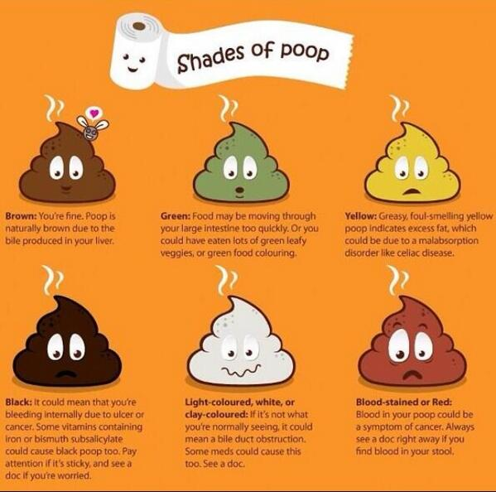
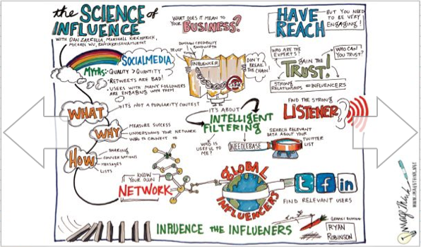

Your visual representation must be:
a. In colour
b. Hand-drawn
c. Effortful! (don’t rush)
d. Chock full of information!
e. Corner-to-corner info! BBBB (Big, bright, bold, and beautiful!)

3. SHARE
You are your partner are expected to clearly present your research findings in front of the class in a 2-3 minute presentation. Your work will then be on display in our classroom!

Names: _____________________________________________________

Reference this checklist if you’re interested in getting a decent mark!

Research (Understands and makes connections)
- Is my research thorough?
- Have I stayed on topic?
- Did I gather an appropriate amount of sources? (about 3)
- Did I answer appropriate questions in my research?

Represent (Analyzes scientific information)
- Was I able to analyze and synthesize my research into a meaningful, visual format?
- Did I include a good amount of interesting, important, and relevant info?
- Does my info-graphic take up the whole page?
- Is it in colour?
- Does my effort show? (or did I rush)

Share (Develops skills for inquiry and communication)
- Did my partner and I effectively share our research?
- Did we explain our info-graphic in a clear manner?

You must list your internet sources. You may use the rest of the space on this page if you want.
Follow this guide to list all of your sources:

Article author’s last name, Article author’s first name
“Title of article” (put the title in quotation marks). Date of Internet publication
http://address/filename, Date of download

Example:
Grouch, Oscar The
“How to be grumpy all the time”, December 25, 2015
http://www.beagrouch.com, Nov 8, 2017

