Linear Relations Unit

In this unit, you will learn to do the following:

Lesson 1: REPRESENTING PATTERNS
- Represent pictorial, oral and written patterns with linear equations
- Recognize a situation where a linear relation is present
- Solve problems that involve pictorial, oral, and written patterns using a linear equation.
- Verify linear equations by substituting values

Lesson 2: INTERPRETING GRAPHS
- Describe the patterns found in graphs by identifying them as either linear or non-linear
- Extend graphs to determine an unknown value using extrapolation
- Estimate values between known values on a graph using interpolation
- Estimate values beyond known values on a graph

Lesson 3: GRAPHING LINEAR RELATIONS
- Graph linear relations
- Match equations of linear relations with graphs
- Solve problems by graphing a linear relation and analyzing the graph

Lesson 1: REPRESENTING PATTERNS

Pictoral Pattern Example: The following is a pictoral representation of a linear pattern.
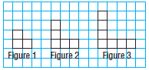
A) Determine the linear equation represented by the pattern.

Step 1: Create a table of values to recognize the pattern between the first three figures
Input  Figure Number  (x) | Output  Number of Squares  (y)
1 | 3
2 | 5
3 | 7

Step 2: Determine the difference between the output values. What are they increasing or decreasing by? This is your numerical coefficient.
Increasing by 2 therefore the numerical coefficient is positive 2
2x

Step 3: Determine the “zero”th value. This is your constant.
If the input is zero then the output is one (3-2=1). Therefore the constant is 1

Step 4: Write your linear equation in the form of y=mx+b where m is the numerical coefficient and b is the constant.
y=2x+1

Step 5: Verify your linear equation is correct by substituting the input value for x and checking your output value is correct.
Input  Figure Number  (x) | Output  Number of Squares  (y) | y=2x+1
1 | 3 | 2(1)+1 = 3
2 | 5 | 2(2) +1 = 5
3 | 7 | 2(3) +1 = 7

B) Determine the number of squares in the 25th figure.

Substitute the value into your linear equation. Do not forget BEDMAS
For the 25th figure:
y=2x+1
y=2(25)+1
y=50+1
y=51
There will be 51 squares in the 25th pattern.

C) Determine which figure has 75 squares.

Substitute the number of squares into the output of your linear equation.
75 = 2x + 1

Remember when you are solving for a variable, isolate the variable on one side and the constant on the other side of the equals sign. Use opposite operations to combine like terms on the opposite sides of the equations

75-1 =2x +1 -1 subtract 1 from both sides of the equation
74 =2x divide 2 from both sides of the equation
37 = x
There are 75 squares in the 37th figure.

Written Pattern Example:
On top of the $45 monthly fee, Sam’s cell phone plan charges $0.15 for every text message he sends or receives.

A) Develop an equation to calculate the monthly bill.

B) Complete a table of values comparing the number of text messages and
the monthly cost for 1, 2, 3, 4, and 5 text messages sent.

C) What would Sam’s bill be if there were 20 text messages in a month?

D) If Sam budgets $80 a month for his cell phone, how many text messages can he send or receive each month? Explain.

SUMMARY-How can we tell if a linear relation is present?
Practice: Worksheet 6.1
LESSON 2: INTERPRETING GRAPHS

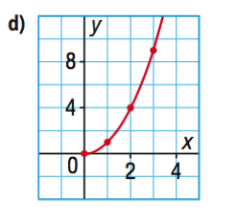
Circle which of the following graphs show linear relations:
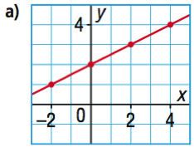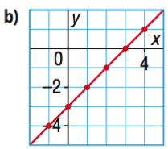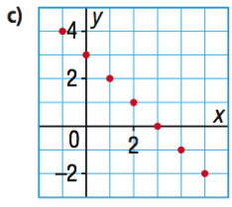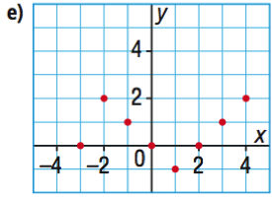

Graphically, linear relations are straight lines.

Graph the following table of values

Does the data follow a linear pattern? Why or why not?

Does the data follow a linear pattern? Why or why not?
EXAMPLE 1:
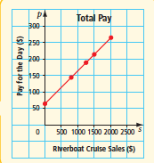
Richard is paid a daily salary and commission to sell riverboat cruises.

As a salesperson, he recognizes that it is important to know his sales in order to determine his commission. He creates the following graph.

A) What does the variable p represent?

B) What does the variable s represent?

C) How much is Richard paid if he does not sell any riverboat cruises in a day?

D) What do the data points (dots) on the graph represent?

E) What does the line represent?

F) Predict Richard’s pay if he makes $500 of sales in a day.

interpolation-

G) Predict Richard’s pay if he makes $2500 of sales in a day graphically.

extrapolation-

H) If the linear relation is represented by p=$\frac{s}{10}$ +64 verify your answer to G by substitution.

I) Solve graphically: How much in riverboat sales did Richard make if was paid $250 in a day. Did you use interpolation or extrapolation?

J) Solve algebraically: How much in riverboat sales did Richard make if was paid $250 in a day.
EXAMPLE 2:
A weather balloon recorded the air temperature at different altitudes.
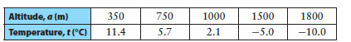
What is the manipulated variable? Graphed on the ____________________________-axis.

What is the responding variable? Graphed on the ____________________________-axis.

Graph the data. (Note the negative values)

- Interpolate the approximate value for the air temperature when the balloon was at a height of 600m.

- What was the approximate altitude of the balloon at an air temperature of −7.5°C? Did you use interpolation or extrapolation?

- Is it possible to interpolate the precise value for the air temperature when the altitude is 1050.92m? Explain.

PRACTICE: Worksheet 6.2
Graphing horizontal or vertical lines
Sometimes a linear relation doesn’t show itself as a diagonal line, but instead as a vertical or horizontal line.

EXAMPLE 1: Based on the graph below, answer the following questions:
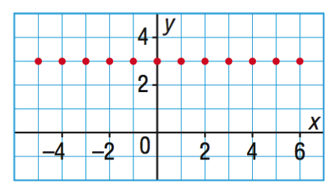
- Is this a linear relation?

- Fill in the following table of values based on the graph

x | y
-4
-2
0
2
4
6
- Does the y value change? Therefore the numerical coefficient in the linear equation is
- The linear equation of the above graph is y=

A horizontal line always takes the form of y=b where b is the constant.

EXAMPLE 2: Vertical Lines
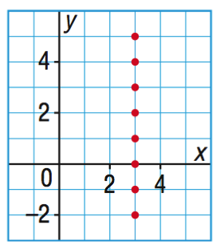
A)Is this a linear relation?
B)Fill in the following table of values based on the graph
x | y
3 | -2
3 | -1

C) Does the x-value change?

D) Is there a “0th value”? Does the line cross the y-axis?

E) The linear equation of the above graph is x=

A vertical line always takes the form of x= number

Sketch the graph of x−7=0

Sketch the graph of y+2=0

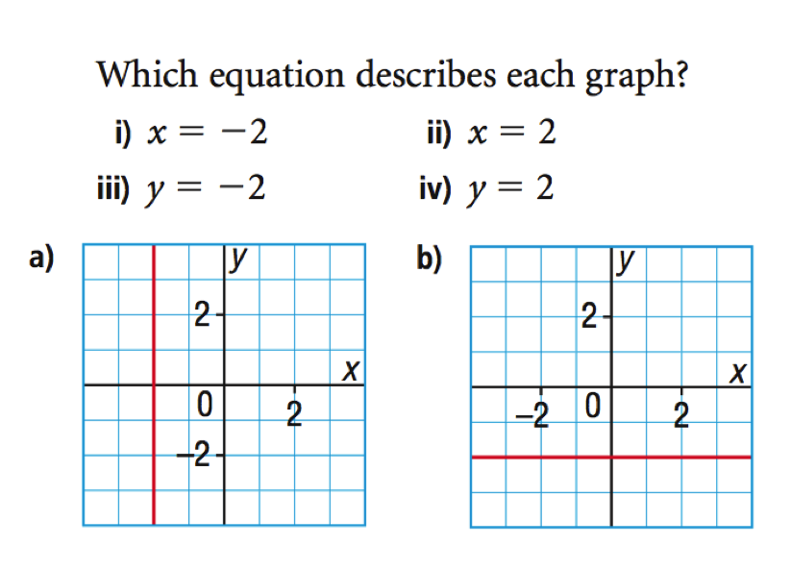

LESSON 3: GRAPHING LINEAR RELATIONS
Graph y=3x-6
To graph a linear relation from an equation
STEP 1: Create a table of values
STEP 2: Solve the corresponding y-values and record in the table
x | y
EXAMPLE 2:
The world’s largest cruise ship uses fuel at a rate of 12800kg/h. The fuel consumption, f, in kilograms, can be modeled using the equation f=12800t, where t is the number of hours travelled.

A) Create a table and a graph to represent the linear relation for the first 7 hours

B) Approximately how much fuel is used in 11h? Verify your solution by solving algebraically.

C) How long can the ship travel if it has approximately 122 000kg of fuel? Verify your solution algebraically.

EXAMPLE 3: Determining a linear equation from a graph

Great Slave Lake, which is located in the NWT is the deepest lake in North America. It has a maximum depth of 614m. Sam decided to check the depth using his fish finder. He collected data up to a depth of 180m and graphed it as follows:
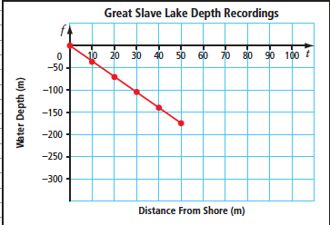
- What linear equation does this graph represent?

- How can you verify the above linear equation?

- If this pattern continues, how far from shore would Sam be when the water is 614m deep?

- At what rate is the depth of the water decreasing?

Practice Worksheet 6.3 and Linear Relations Review

