Great Websites to use for review:
http://highered.mheducation.com/sites/0070973407/student_view0/index.html
https://questaplus.alberta.ca/PracticeMain.html#
http://www.learnalberta.ca
[Note: For all Learn Alberta searches below, perform search under Subject: Mathematics, Grade: 9]

Number Concepts

Objective 1: Give examples of numbers that satisfy the conditions of natural, whole, integral and rational numbers, and show that these numbers comprise the Real number system.

N – Natural numbers 1, 2, 3, 4 … W- Whole numbers 0,1, 2, 3 …
I – Integers … -3, -2, -1, 0 , 1, 2, 3…

R - Rational Any number which can be written in the form .

Irrational Numbers (Not part of the Venn diagram.) Any number which can not be written in form .
This included non-repeating , non-terminating decimals.
Rational
Integers
Whole

Natural

Objective 2: Students will be able to answer questions involving square root and give examples of situations where answers would involve the positive ( principal) square root, or both positive and negative square root.

Problems involving square root – For example: Finding the side length of a square when the area is given.

Calculate the following: and

Objective 3: Compare and order rational numbers.

Example – Compare and write the numbers in descending order. , , , 0.72, and

Objective 4: Do BEDMAS with rational numbers (with and without technology).
Example – Calculate the following. a)

b) –6.2 + (–0.72) ÷ (–1.3 + 0.4)

Objective 5: Explain and apply the exponent laws for powers.

Product Law Zero Exponent Property Quotient Law Power of Quotient Law Power of a Power Law Power of a Product Law

Web Link: http://argyll.epsb.ca/jreed/math9/strand1/1105.htm

Objective 6: Be able to apply one or more exponent law to simplify an expression. You must be able to express your answer in positive exponents only.

Example: (–4)2 ! (–4)2 ! (–4)4 ÷ (–4)2![(–4) 3] 4

Objective 7: Solve problems using rational numbers in meaningful contexts.
- make sure you know how to solve decimal, percent, fraction and logic problems.
- Solve problems of various context using charts, graphs, expressions and equations.

Example -For every metre a scuba diver dives below the water surface of a lake, the light intensity is reduced by 5%. The percent of light intensity can be represented by the equation I = 100(1 – 0.05)d, where I is the intensity of light, as a percent, and d is the depth of the dive, in metres. The intensity of light at the surface of the lake is 100%. Austin wanted to determine the light intensity at a depth of 3 m. His solution is shown below.
I = 100(1 – 0.05)d
I = 100(1 – 0.05)3
I = 100(13 – 0.053) I = 100(0.999875) I " 100
Austin realized that it is not possible for the light intensity to be approximately 100% at a depth of 3 m. Explain where
Austin made his mistake.

Objective 8: Explain the meaning of biased and unbiased.

Objective 9: Define population and sample. Select and defend the choice of using either a population or a sample of a population to answer a question.

Example: For each situation:
• Identify the population.
• Decide if you would survey the population or a sample. Justify your choice.

a) Determine the number of Arctic grayling in Lake Athabasca.

b) Determine if the owners of a riding arena can recover the cost of a new roof by increasing the rental cost of the arena.

Objective 10: Describe th effect of bias, use of language, ethics, cost, time and timing, privacy, cultural sensitivity on the collection of data.

Example: For the situation, identify and describe any factors that may influence the collection of data.
The coach of a baseball team needs drivers with good safety records to transport players to tournaments. She asks each parent at a parent meeting if they had any traffic violations in the last six months.

Objective 11: Describe the types of sample (stratified, random, systematic and convenience.) Objective 12: Understand the role of probability in society.

Example: 3. Cal randomly surveys 100 students about their favourite subject. There are 500 students in the school. The table displays the results.

Subject | Math | English | History | Science
Total | 30 | 35 | 13 | 22

a) What is the theoretical probability that a student will choose math?
b) What assumptions did you make?
c) Based on the survey results, predict how many of the 500 students prefer math. Show your calculations.

Objective 12: Define all algebra vocabulary (variable, constant, numerical coeffiecient, linear relation, linear equation, expression, etc.)

Objective 13: Find the pattern using a linear equation and verify.

Example: Draw the next two figures in this series.

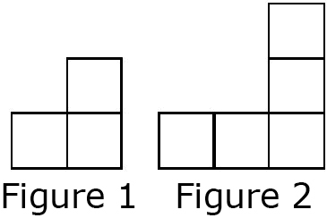
b) Create a table of values comparing the number of squares and the figure number.
c) Describe the pattern.
d) Write the equation that represents this pattern. e) How many squares are in Figure 15?
f) Which figure number has 69 squares?

Objective 14: Graph a linear relation, analyze it, and interpolate or extrapolate.

Example: For the linear equation b = –2a – 15, create a table of values then graph.

Objective 15: Solve equations and identify equivalent forms of a given algebraic expression or equation. Students must be able to use algebra tiles to solve equations.
Examples:
x + 6 = 10 4x + 2 = 3t + 12
3x + 5 = 10 13( x + 4) = 15y

Objective 16 : Simplify algebraic expression and equation.
3 ( x + 2 ) – ( x + 3x )
= 3x + 6 – x -3x
= 6 – x

Objective 17: Solve inequalites and display solutions on a number line.

-2 -2

-4 -4

1 2 3 4 5 6
Closed dot includes the number and white dot does not

( switch sign when dividing by a negative)

Objective 18: Solve various equation problems.
- set up an equation to solve problems
- distance questions, rate of work problems, money questions.
include the number

Ex The perimeter of a rectangle is 40 cm. The length is 2 cm more than 5 times the width. What are the dimensions of this

rectangle?

Let the width = w
Let the length = 5w +2
5w+2
w w
5w+2

(W )+ (W) + (5W+2)+(5W+2) = 40
12w + 4 = 40
-4 -4
12w = 36
w=3 The width is equal to 3 cm and the length is equal to 17

Objective 19: Define all polynomial vocabulary (monomial, binomial, trinomial, polynomial, numerical coefficient, variable, constant, term, like terms and degree.)

Objective 20: Combine like terms.
Website: http://library.thinkquest.org/20991/alg2/polyf.html

Ex) Collect like terms. 3m – m2 – 6 + 3m2

Objective 21: Add and subtract polynomials pictorially and symbolically (algebraically.)
Ex) Simplify the polynomials. a) (3x2 –2x) + (x2 + x)
b) (4k2 – 6k + 1) – (–2k2 + 5)

Objective 22: Multiply and divide monomials by monomials pictorially and symbolically.
Ex) Simplify.
a) (6m)(–0.2m)

b)

Objective 23: Multiply monomials by polynomials pictorially and symbolically.
Ex) Expand. (5m)(2m + 3)

Objective 24: Divide polynomials by monomials pictorially and symbolically.
Ex) Divide.

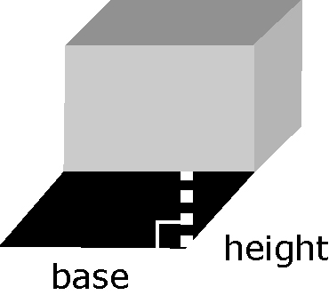
Objective 25: Solve word problems involving the addition, subtraction, mulitplication and divison of polynomials (i.e. Perimeter, Area, Surface Area and Volume.)
Ex) The area of a parallelogram can be calculated by multiplying the base by the height. The area of the shadow can be represented by the expression (12x2 + 3x) cm2. The base of the box can be represented by the expression 3x cm. What is the expression, in simplified form, for the height of the shadow?

Objective 26: Define all circle geometry terms (inscribed angle, central angle, arc of a circle, perpendicular bisector, chord, radius, diameter and tangent to a circle.)

Objective 27: Know the relationship between inscribed angles and central angles when subtending the same arc .
Weblink: http://members.shaw.ca/ron.blond/Circle.Geom1.APPLET/index.html

Objective 28: Know the relationship between inscribed angles when they are subtending the same arc .
Weblink: http://members.shaw.ca/ron.blond/Circle.Geom1.APPLET/index.html
Weblink: http://www.coolmath.com/reference/circles-geometry.html

Objective 29: Solve problems using the circle properties.
Ex) A subway track must pass through a cylindrical tunnel. The tunnel is 6 m in diameter. How wide should the track bed be so that the maximum height at the centre of the tracks is 4.5 m? Express your answer to the nearest tenth of a metre.

4.5 m

Objective 30: Find the surface area of a composite 3D object to solve problems.
Ex) The following object has been drawn on isometric dot paper, where the distance between dots is 2 cm. Find the surface
area of the object. 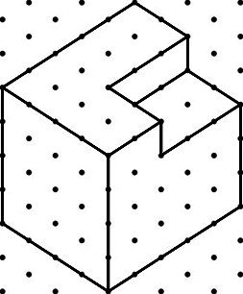

Objective 31: Solve problems involving similar polygons/scale diagrams.
Ex)The trapezoid is a scale drawing of a cattle pasture. The actual length of the shortest side of the pasture is 200 m.
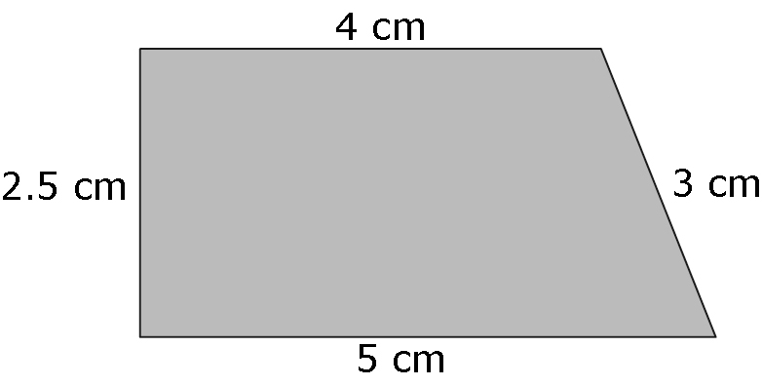

Objective 32: Understand the meaning of line symmetry and rotation symmetry.
Ex) Colin was visiting the museum with his math class when he found this piece of artwork.
a) Help Colin identify the lines of symmetry by drawing them in and labelling the lines.
b) Colin recognized that the artwork displays rotation symmetry. Identify the order and the angle of rotation.

Math PAT Date:

