GRADE 9 FIGURES OF SPEECH VISUAL DICTIONARY
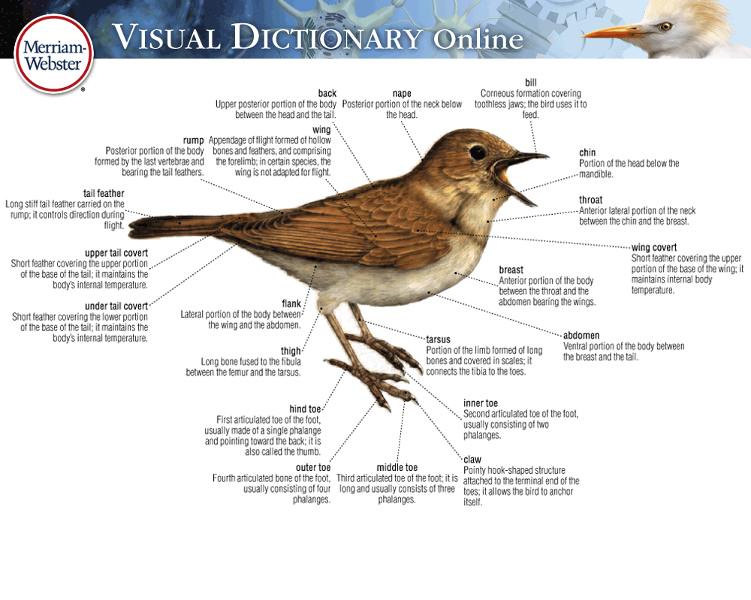
ASSIGNMENT INTRODUCTION
A visual or picture dictionary is a dictionary that has been illustrated with diagrams that help support and explain the definitions of the words. Typically they are a device used by new language learners and as such are often published as multilingual texts.

ASSIGNMENT OBJECTIVE
For this assignment, you are to create a visual dictionary for a variety of figures of speech. This assignment has a written component and a visual component.
- For the written component, you will be creating a page for each figure of speech. Each page is to include the definition and an original example for the respective figure of speech.
- For the visual component, you are to create a dictionary title page and an image on each page to visually represent each figure of speech example you have created.

The purpose of the assignment is to build upon your figure of speech knowledge and to demonstrate your skill in effectively using them in context.

ASSIGNMENT REQUIREMENTS – “My visual dictionary…”
THE WRITTEN COMPONENT
- … has a figure of speech as a title for each page.
- … pages each contain the proper definition of their figure of speech.
- … pages must each contain an original example of their figure of speech.
- … pages must not contain any spelling or punctuation errors.
THE TABLE OF CONTENTS
- … has a table of contents that:
  - must include a list of the figures of speech.
  - has their page numbers.
THE DICTIONARY PAGES
- … must include a page for each figure of speech listed below.
- … pages must each contain the required written content (see Written Component).
- … pages must be neat and carefully completed.
THE VISUAL COMPONENT
- … must include a title page.
- … title page must include a relevant picture.
- … must be neat and carefully completed.
- … title page have a creative design.
- … title page must include a relevant picture.
- … pages must have a creative design.
- … pages must make good use of the page space.
- … pages must each contain a picture that visually represents the given example.
- … pages must be colourful.

Figures of Speech to include in dictionary:
- ALLITERATION | - MALAPROPISM
- ALLUSION | - METAPHOR
- ANALOGY | - ONOMATOPOEIA
- APOSTROPHE | - OXYMORON
- EUPHEMISM | - PARADOX
- HYPERBOLE | - PERSONIFICATION
- IMAGERY | - PUN
- IRONY - VERBAL | - REPETITION
- IRONY - SITUATIONAL | - SIMILE
- IRONY - DRAMATIC | - UNDERSTATEMENT

Criteria | 4 | 3 | 2 | 1
Definitions  Accuracy of the definition of the figures of speech  Definitions in your own words.  Concise definitions | Definitions are accurate and all definitions are detailed.  All definitions are in your own words and all are conscise. | Definitions are accurate and most are detailed  Most definitions are in your own words or are concise. | Definitions are somewhat accurate.  Some definitions are in your own words. | Only a few definitions are accurate.  Missing terms/definitions.  Definitions are not in your own words.
Illustrations/Visual Component  Quality of illustrations  Appropriateness of illustrations | All illustrations are hand drawn with craftsmanship and care.  Illustrations are coloured with care.  All pictures are appropriate given the figure of speech and example. | Most illustrations are drawn with craftsmanship and care. Some illustrations show inattention to detail.  The majority of pictures are appropriate given the figure of speech and example. | Some illustrations are drawn with craftsmanship and care. Illustrations show inattention to detail and a sense of being rushed.  Some of the illustrations do not represent the figure of speech or the example given. | Illustrations are not done with care or completed with inattention to detail. Illustrations may also be missing.  Illustrations do not represent the figure of speech or the examples given.
Examples  Originality of your examples.  Appropriateness of examples | Original examples are provided for all figures of speech. Examples are unique and well thought out.  All examples appropriately match the figure of speech. | Most of the examples are original. Examples are well thought out.  Most of the examples match the figure of speech. | Some examples are original while other examples are common or not well thought out.  Some examples do not appropriately illustrate the given figure of speech. | Examples are not original and are commonly found. Examples may also be missing for some figures of speech.  Examples do not appropriately illustrate the given figure of speech.
No grammatical or mechanical errors | Product shows that it was proof-read or peer-edited and does not contain grammatical or mechanical errors. Care was taken to have a perfected final copy. | Product shows that it was proof-read or peer-edited however minor errors remain that do not detract from the intended meaning. | Product was not proof-read or peer-edited. Major errors exist that at times detract from the intended meaning. | Product was not proof-read or peer-edited. Major errors exist throughout the product that detract from the intended meaning.  It is obvious that little care and effort was taken in the product.

