GRADE 9 FIGURES OF SPEECH VISUAL DICTIONARY
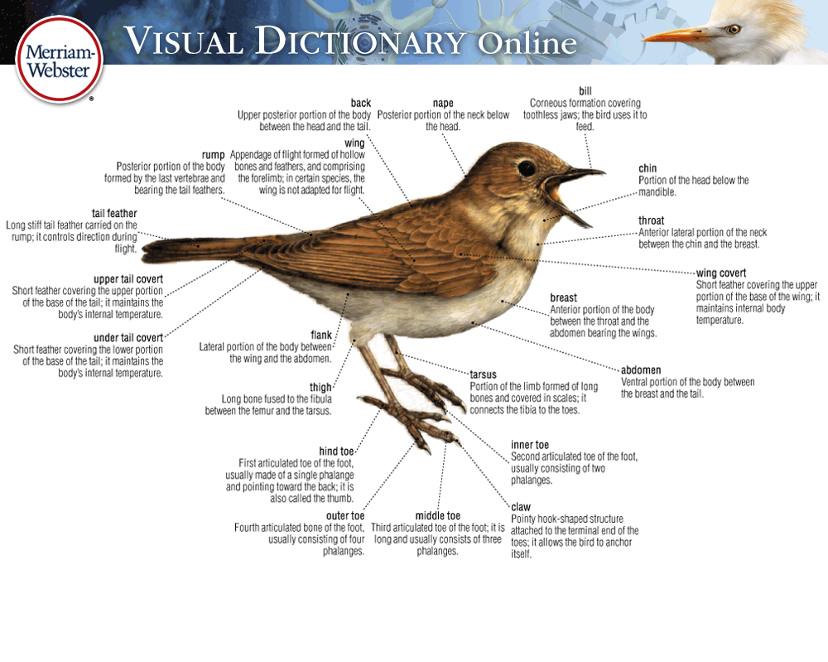
ASSIGNMENT INTRODUCTION
A visual or picture dictionary is a dictionary that has been illustrated with diagrams that help support and explain the definitions of the words. Typically they are a device used by new language learners and as such are often published as multilingual texts.

ASSIGNMENT OBJECTIVE
For this assignment, you are to create a visual dictionary for a variety of figures of speech. This assignment has a written component and a visual component.
- For the written component, you will be creating a page for each figure of speech. Each page is to include the definition and an original example for the respective figure of speech.
- For the visual component, you are to create a dictionary title page and an image on each page to visually represent a literal image of each figure of speech example you have created.

The purpose of the assignment is to build upon your figure of speech knowledge and to demonstrate your skill in effectively using them in context.

ASSIGNMENT REQUIREMENTS – “My visual dictionary…”
THE WRITTEN COMPONENT
- … has a figure of speech as a title for each page.
- … pages each contain the proper definition of their figure of speech.
- … pages must each contain an original example of their figure of speech.
- … pages must not contain any spelling or punctuation errors.
THE TABLE OF CONTENTS
- … has a table of contents that:
  - must include a list of the figures of speech.
  - has their page numbers.
THE DICTIONARY PAGES
- … must include a page for each figure of speech listed below.
- … pages must each contain the required written content (see Written Component).
- … pages must be neat and carefully completed.
THE VISUAL COMPONENT
- … must include a title page.
- … title page must include a relevant picture.
- … must be neat and carefully completed.
- … title page have a creative design.
- … title page must include a relevant picture.
- … pages must have a creative design.
- … pages must make good use of the page space.
- … pages must each contain a picture that visually represents the given example.
- … pages must be colourful.

Figures of Speech to include in your dictionary
- ALLITERATION | - MALAPROPISM
- ALLUSION | - METAPHOR
- ANALOGY | - ONOMATOPOEIA
- APOSTROPHE | - OXYMORON
- EUPHEMISM | - PARADOX
- HYPERBOLE | - PERSONIFICATION
- IMAGERY | - PUN
- IRONY - VERBAL | - REPETITION
- IRONY - SITUATIONAL | - SIMILE
- IRONY - DRAMATIC | - UNDERSTATEMENT

Rubric
 | 4 | 3 | 2 | 1
Writing  - spelling  - grammar  - punctuation  - flow  Stem 2 | The writing in the project is flawless.  It is clear that the work has been edited. | The writing has minimal errors, which do not detract from the final product.  It is clear the work has been edited. | The writing has errors which are sometimes distracting. Student needs to edit the work further. | The work has many distracting errors.  Student must work on editing through the COPS technique, and by reading out loud.
Presentation/Visual  - cover page  - pictures  - neatness  Stems 3 and 6 | The visual portion perfectly represents a literal expression of the figure of speech. | The visual portion effectively represents a literal expression of the figure of speech, but could be improved with more details. | The visual portoin represents the figure of speech, but does not effectively portray a literal expression of it.  OR the image is lacking detail. | The visual is not related to the example.
 | The assignment is professional, clean, proper, and well-organized.  It is clear you’ve gone the extra step to make this project excellent. | The assignment is clean, proper, and well-organized.  It is clear you’ve taken great pride and care in this work. | The assignment is mostly clean and proper, but may be lacking some neatness or organization. | The assignment is untidy, or not neat at all.
Communication  - definitions  - clarity  - effectiveness  Stem 10 | Each figure of speech is correctly and clearly defined in grade nine language. | Each figure of speech is correctly defined. | Each figure of speech is defined, however some may be lacking clarity and detail. | The assignment is missing figures of speech.
 | The example is original, and creatively epresses the figure of speech. | The example is original, and expresses the figure of speech. | The example expresses the figure of speech, but may not be ompletely original. | The assignment is missing examples.

