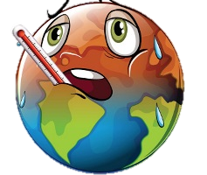
Government vs. Free Market - The Environment
Issue | Government Solutions to Issue – What Could the Government Do?
Climate Change | What could the government do to address climate change?
Health Hazards | What could the government do to address hazards to health – toxic chemicals in waterways, toxic air pollution, etc.?
Waste Challenges | What could the government do to address excessive human waste?

Issue | Free Market Solutions to Issue – What Could Individuals / Business Do?
Climate Change | What could the free market do to address climate change?
Health Hazards | What could the free market do to address hazards to health – toxic chemicals in waterways, toxic air pollution, etc.?
Waste Challenges | What could the free market do to address excessive human waste?

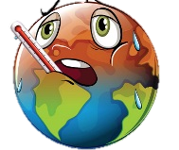
Government vs. Free Market - The Environment
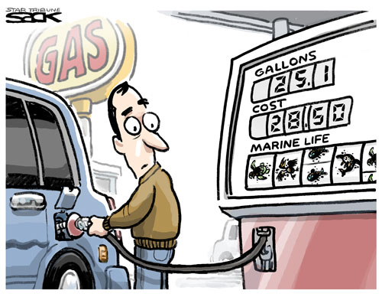 | What is the issue in the cartoon?  Does the cartoonist support a government or free market solution to the issue?  Do you agree with the artist?
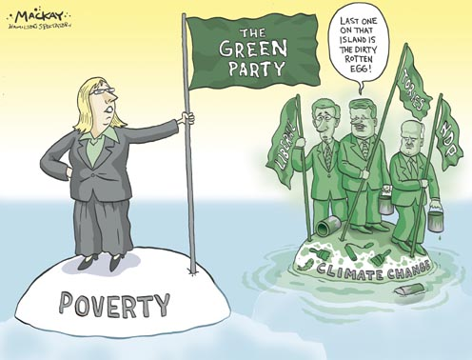 | What is the issue in the cartoon?  Does the cartoonist support a government or free market solution to the issue?  Do you agree with the artist?
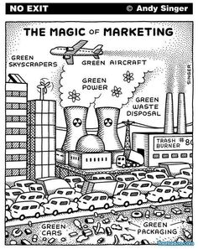 | What is the issue in the cartoon?  Does the cartoonist support a government or free market solution to the issue?  Do you agree with the artist?
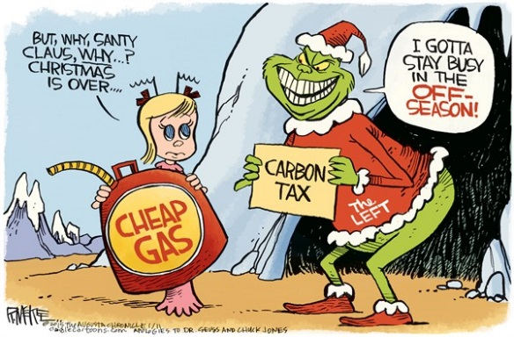 | What is the issue in the cartoon?  Does the cartoonist support a government or free market solution to the issue?  Do you agree with the artist?

