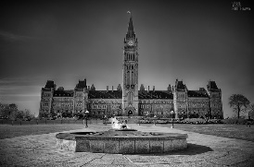
Welcome to Grade 9 Social Studies!

How much do you know about your country? Answer the following questions based on your current knowledge of Canadian Government, politics and economics, as well as current world events. You may use the internet and any other resources available within the classroom to answer these questions. The first group to successfully complete the following scavenger hunt will win a prize!

- Name three major Political Parties in Canada, and the leaders of each political party:

- List three things that a person needs in order to be eligible to vote in a Canadian election:

- Who is the current Governor General of Canada:

- Who was the sixth Prime Minister of Canada? What political party did he lead?

- Name three important International News Stories which occurred over the summer

- Name three important Domestic News Stories which occurred over the summer

- List what you feel is one of the most important rights / freedoms you have as a Canadian citizen as seen in the Canadian Charter of Rights and Freedoms:

- What is a refugee? Name a country which Canada is currently accepting refugees from:

- What are Economics?

- Define Scarcity?

