Circle Geometry (textbook Chpt. 8)

Utilize geometric relations to calculate angle sizes and side lengths.
- 180º rule - pythagoras’ theorem - straight angle
- complementary angles - supplementary angles

Sketch/Explain OR diagrams that …
Determine angle sizes or lengths in

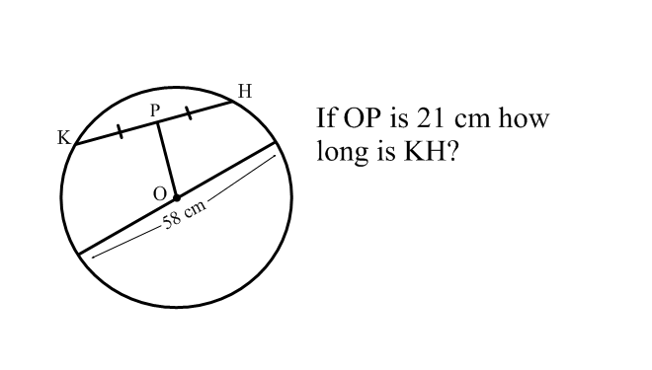
Have a chord that is bisected by a segment that passes through
the center of a circle.

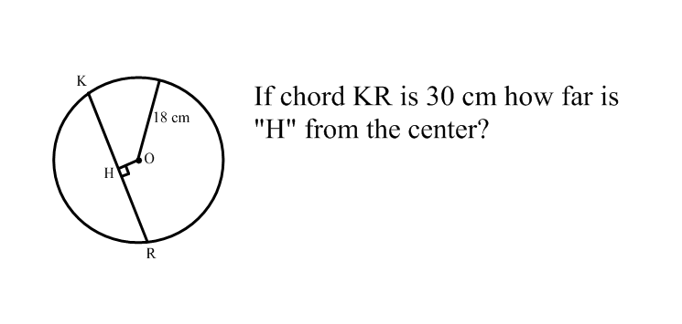

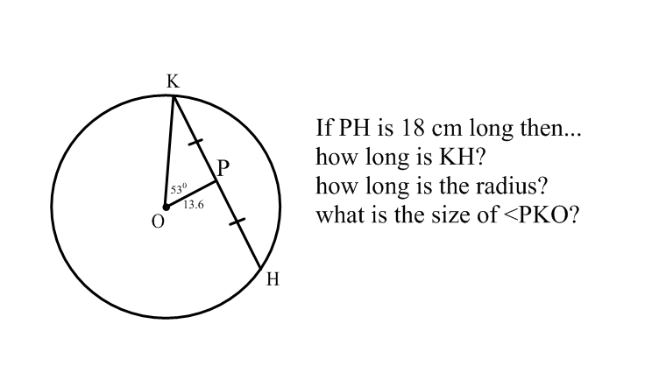

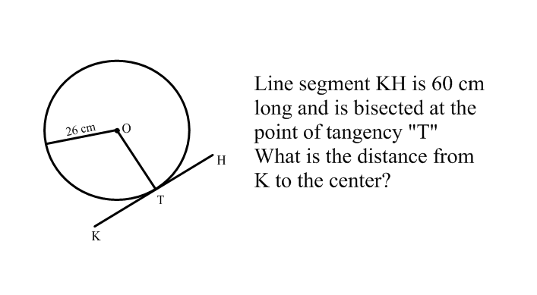
Have a tangent line that perpendicularly intersects the point of
tangency with a segment that passes through the center.

Have two or more inscribed angles that are subtended by the
same arc

OR

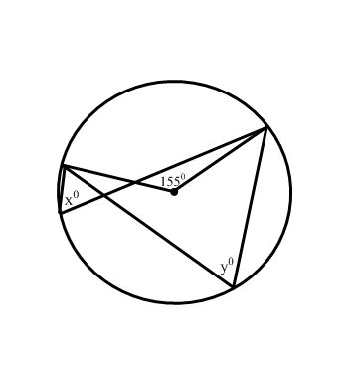
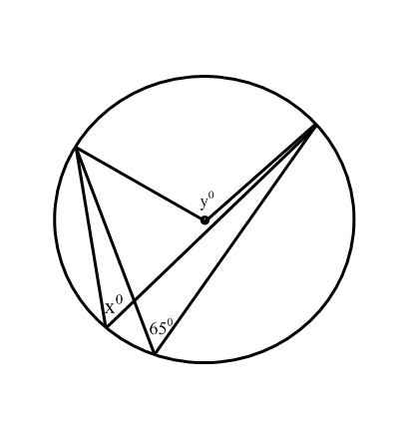
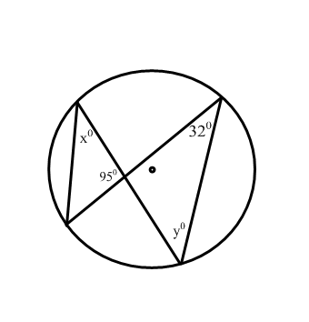
Have an inscribed angle and central angle that are subtended by
the same arc.

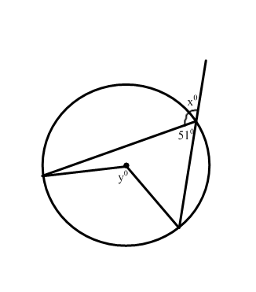
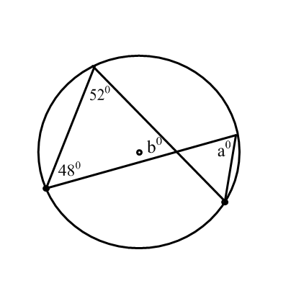
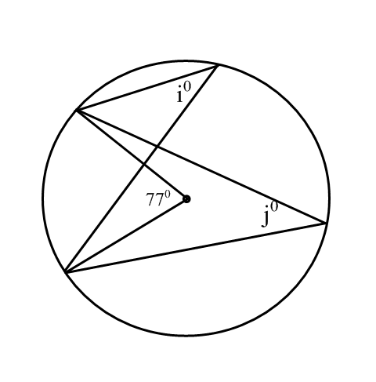
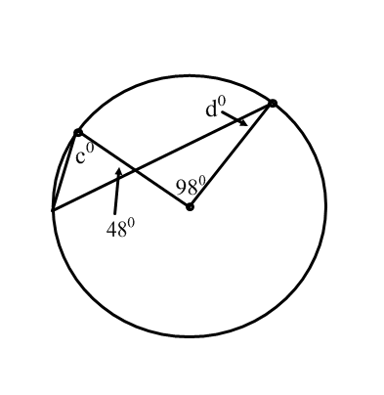

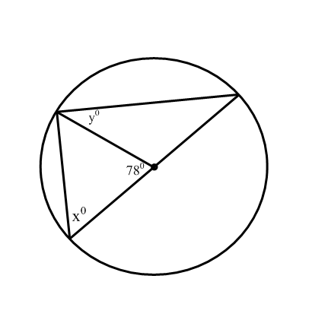
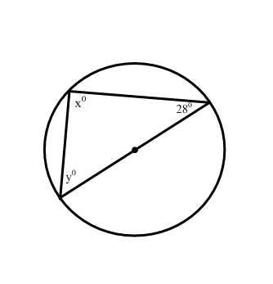
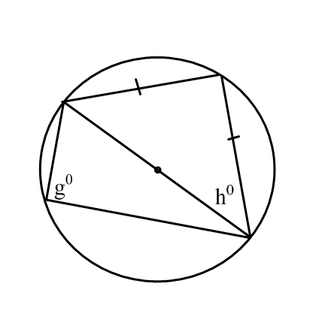
Have an inscribed angle that is subtended by a semi-circle.

Additional Review/Practice can be found in the textbook on the following pages…
Study Guide – pg. 307
Extra Practice - pg. 417; pg. 418-419

