Chemistry Intro

Chemistry is the science of matter.

Matter is anything that has mass or volume

Mass is how much matter is in an object. Mass is different than weight. (measured in g, kg, mg, etc.)

Volume is how much space something takes up.

3 states of matter – solid, liquid, gas

Changes of state… melting, evaporation, freezing, etc.

Particle theory – created to describe the structure and behavior of matter
- All matter is made up of tiny particles
- All particles have spaces between them
- All particles of one pure substance are the same. Different substances are made up of different particles
- The particles are always moving. More energy the particles have, the faster they move
- There are attractive forces between the particles. These forces are stronger when the particles are closer together.

Related to states of matter
- as energy is added, particles move around more.
- Weakens bonds between particles

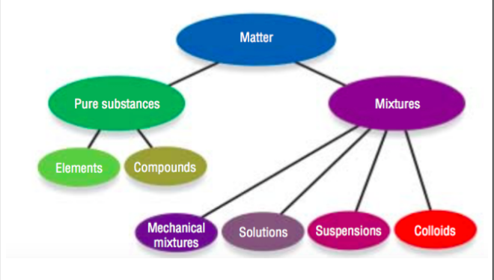

Pure substances – contain only one type of matter. Will have a specific set of physical and chemical properties
Can be elements or compounds

Elements – particles that cannot be broken down chemically. Found on periodic table of elements.
Compounds – made of 2 or more elements bonded together chemically (hydrogen plus oxygen). Can be broken apart in chemical reactions.

Mixtures – contain at least 2 or more pure substances that do not join together chemically

Mechanical mixtures (heterogenous)– mixtures where the ingredients can be easily seen (pizza)

Solutions (homogenous) – 2 or more ingredients mixed that you cannot tell apart. (sugar in water) (solute-sugar, solvent-water… brass – mixture of copper and zinc (alloy)

Suspensions – cloudy mixtures where tiny particles are seen. (sand and water)
Colloids – same as suspensions but tinier particles (milk – fat + water)

