First-degree murder charges stayed after four-year court delay

A man charged with first-degree murder has been allowed to walk free due to lengthy delays in his criminal trial, leaving the victim's family frustrated that they will never see justice served in court.
Former Canadian Forces member Adam Picard, 33, was released on the grounds that his right to a speedy trial had been violated, four years after the alleged offence occurred in Ottawa. The Supreme Court of Canada determined in July that a reasonable delay to trial is 18 months for provincial cases and 30 months for cases before the superior court.
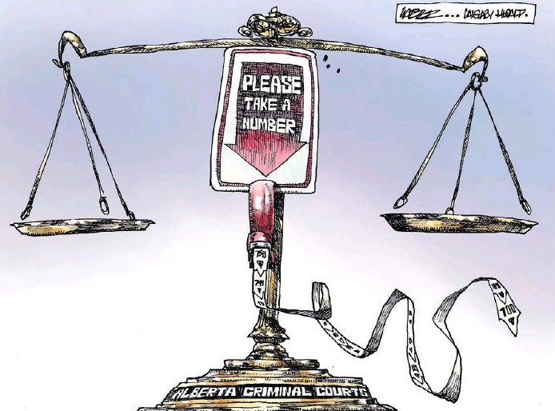

You Have the Right to Offend Me
This week in Nova Scotia, a grade 12 student was suspended from his high school for persistently wearing a T-shirt emblazoned with the words, "Life is wasted without Jesus."
He was told that some teachers and students in the school were offended by the words on his shirt. Then he was told that if the shirt had said "MY life is wasted without Jesus," it would have been different. Really? Surely, that too would offend someone.
Canada's Charter of Rights and Freedoms protects both freedom of religion and freedom of expression, but nowhere does it protect people from feeling offended. As A. Alan Borovoy, general counsel emeritus of the Canadian Civil Liberties Association has said, "The thin skin of one should not be allowed to limit the free speech of another."

Canadian spy agency sued for allegedly violating charter

One of Canada's top spy agencies, Communications Security Establishment Canada, is violating privacy rights under the Charter of Rights and Freedoms, according to a lawsuit filed by the B.C. Civil Liberties Association and the OpenMedia organization.
Speaking on Tuesday morning in Vancouver, representatives for the two civil rights groups said the broad and unchecked surveillance of Canadians by the spy agency is unconstitutional.
The lawsuit argues two aspects of CSEC's operations violate the charter's protections against unreasonable search and seizure, and infringe on free expression, including:
- The interception of the private communications of Canadians.
- The sweeping collection of metadata information produced by Canadians in their everyday activities online and through phone conversations.

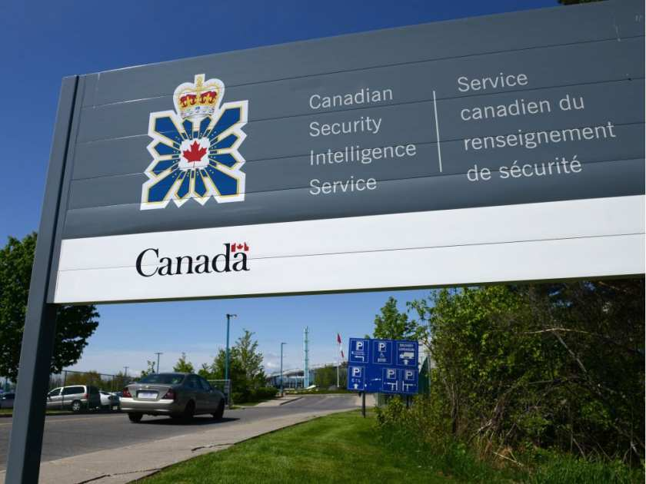

Charter of Rights and the Niqab collide in views on 'Canadian values'
More fuel for those who stereotype Canadians as a dry, boring people.
Statistics Canada said last week that more than 90 per cent of us, when asked, identified the Charter of Rights and Freedoms as an "important symbol of Canadian identity."
According to the government's own polling, 83 per cent of Canadians support forcing a Muslim woman to remove her Niqab to take part in the oath of citizenship.
People are, of course, entitled to hold opinions and to express them.
Section 2 of the charter makes sure of that.
There is good reason to believe it infringes on a number of aspects of Section 2 of the charter — including the right to religion, expression and association — as well as Section 15, which guarantees no one is to be singled out based on religion or gender.
The Canadian Charter of Rights and Freedoms. (Evan Mitsui/CBC) Both of those sections, by the way, guarantee fundamental rights to "everyone," meaning all people residing in Canada whether or not you have become a full citizen yet.

Top court weighing whether assisted suicide protects Canadian rights, or violates them

OTTAWA -- The so-called "right to die" was back on Canada's conscience Wednesday as the Supreme Court confronted the question of whether a ban on assisted suicide protects or violates the fundamental rights of Canadians.
Those arguing for a change in the law say public opinion has shifted dramatically in the more than 20 years since Sue Rodriguez became a household name by taking her fight for a medically assisted death to the top court.
In 1993, the nine-justice panel was split; Wednesday's submissions made it clear that the issue remains as divisive as ever for medical practitioners, religious groups, and even advocates for the rights of the disabled.
Two different groups representing Canadians with disabilities appeared before the court, arguing opposite sides of the case.
