Healthcare Cartoons
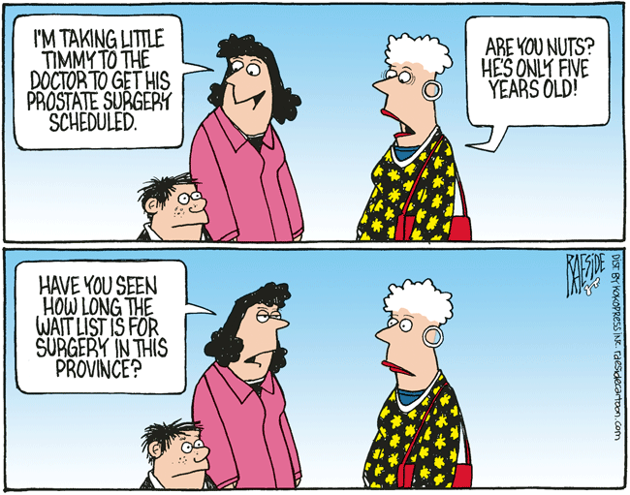 | Critiquing:  Canada USA
 | Main Issue with Healthcare:
Critiquing:
Canada USA
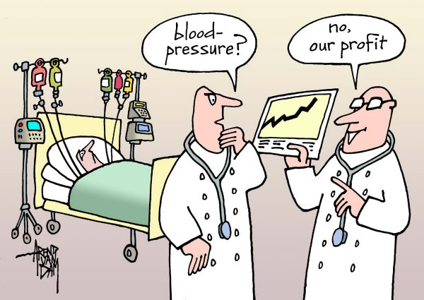 | Main Issue with Healthcare:
Critiquing:
Canada USA
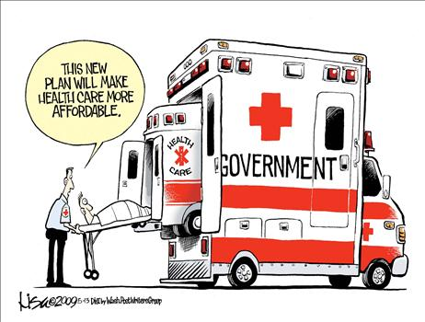 | Main Issue with Healthcare:
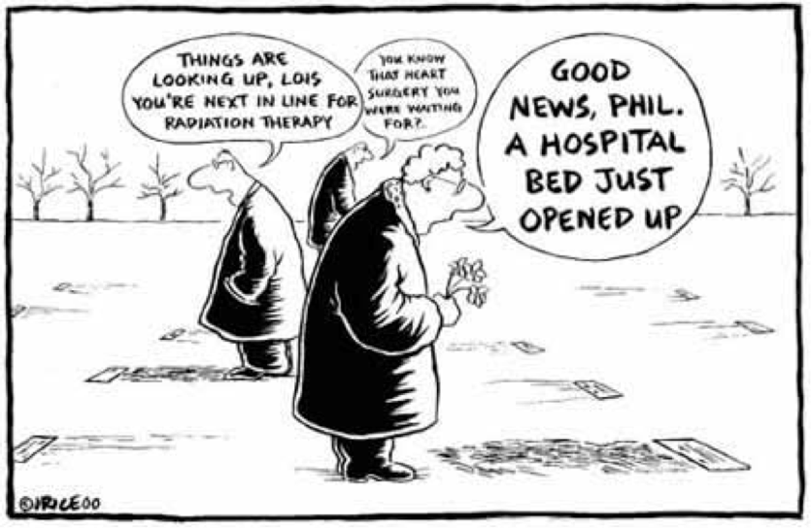 | Critiquing:  Canada USA
 | Main Issue with Healthcare:
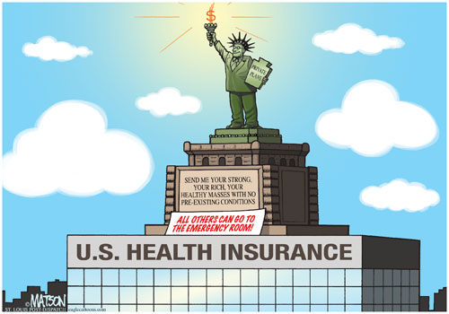 | Critiquing:  Canada USA
 | Main Issue with Healthcare:
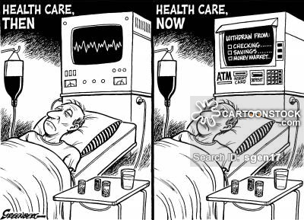 | Critiquing:  Canada USA
 | Main Issue with Healthcare:

