What is an Electrochemical Cell? Virtual Lab

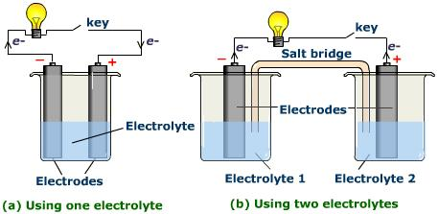

Use the website and links below to answer the following questions.

First go to www.learnalberta.ca
Type in Electrochemical Cell into the Find Resources box.
The link “What is an Electrochemical Cell” will be on the right hand side of the screen.

Work through the tour and answer the following questions. Be sure to click “play” to see all the animations.

- Technically, what is a battery?

- Why are cells wired together?

- What is a 9 V battery made up of?

- A) What are the two types of cells?

B) What is the difference between the two of them?

- Describe the FOUR basic components of electrochemical cells?

a)

b)

c)

d)

6. Draw the final set-up from constructing your own electrochemical cell (remember labels).

Modifying Electrochemical Cells Virtual Lab
Use the website and links below to answer the following questions.
First go to www.learnalberta.ca
Type in Electrochemical Cell into the Find Resources box.
The link “Modifying Electrochemical Cells” will be on the right hand side of the screen.

Work through the tour and answer the following questions. Be sure to click “play” to see all the animations.

QUESTION: How do the changes in _____________________ and ______________________ affect the voltage and current produced by an electrochemical cell?

The four variables we will be testing are:

Variable 1
Vary the selection of electrodes and record the voltage.
Electrode combination | Voltage (V)

Variable 2
Vary the electrolyte solution and record the voltage.
Electrolyte Solution | Voltage (V)

Variable 3
Vary the concentration of the electrolyte solution and record the voltage.

Electrolyte Concentration | Voltage (V)

Variable 4
Vary the temperature of the electrolyte solution and record the voltage.

Electrolyte Temperature (ºC) | Voltage (V)

Conclusion
The electrode combination that produced the highest voltage was _________________ and _______________. The electrolyte solution that produced the highest voltage was ________________________________. The concentration of electrolyte solution that produced the highest voltage would be ____%. The temperature of electrolyte solution that produced the highest voltage was _____ºC.

